Old Windsor Parish Council Planning Addendum

APPLICATIONS TO BE CONSIDERED AT THE MEETING HELD ON
WEDNESDAY 12th MARCH 2025
APPLICATIONS

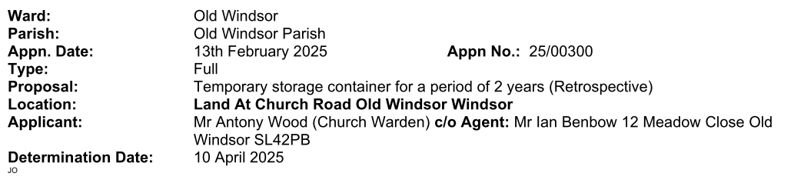

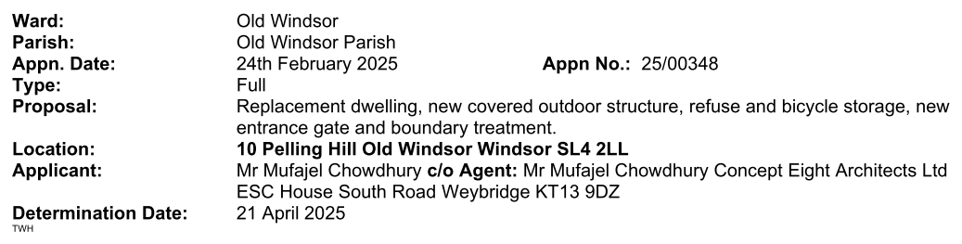

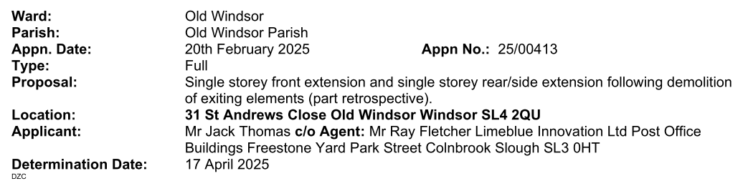

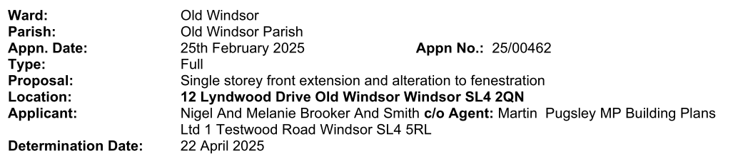

Appn. Date: | 27 February 2025 | Appn. No.: | 25/00344
Type: | Full
Proposal: | Change of use from dwelling house to children's home.
Location: | 27 St Lukes Road Old Windsor Windsor SL4 2QL
Parish/Ward: | Old Windsor Parish/Old Windsor
Applicant: | Mr Colin Smith
Agent: | Mr James Matthewson Chawton Hill Wesley House Bull Hill Leatherhead Surrey KT22 7AH email: info@chawtonhill.com tel: 01372 360 663

Appn. Date: | 28 February 2025 | Appn. No.: | 25/00477
Type: | Full
Proposal: | Change of use of the detached garage for the storage of private motor vehicles and domestic storage and use of adjacent land as amenity/garden not associated with no. 91(Part Retrospective).
Location: | Land Adjacent To 91 Meadow Way Old Windsor Windsor
Parish/Ward: | Old Windsor Parish/Old Windsor
Applicant: | Mr D Hanson
Agent: | Mr Duncan Gibson Duncan Gibson Consultancy 74 Parsonage Lane Windsor SL4 5EN email: duncan@duncangibson.com tel: 01753 307 220

Appn. Date: | 4 March 2025 | Appn. No.: | 25/00509
Type: | Full
Proposal: | 1no.front dormer, 1no. rear dormer and external staircase to provide habitable accommodation within the roofspace ancillary to the main dwelling to the existing garage.
Location: | 29 Burfield Road Old Windsor Windsor SL4 2RB
Parish/Ward: | Old Windsor Parish/Old Windsor
Applicant: | Mr Dan Grifftiths
Agent: | Mr Keith Jewell Bastion Landmark House Station Road Hook RG27 9HA email: keith@wearebastion.co.uk tel: 01256 962 900

Appn. Date: | 3 March 2025 | Appn. No.: | 25/00520
Type: | Full
Proposal: | Two storey side/rear extension with rear Juliet balconies, first floor side extension, alterations to the external finish and fenestration, raised terrace with side steps and enlargement of the existing hardstanding following the demolition of the existing rear two storey extension.
Location: | Sheelin Cottage 4 Straight Road Old Windsor Windsor SL4 2RL
Parish/Ward: | Old Windsor Parish/Old Windsor
Applicant: | Elizabeth Bayle
Agent: | Mr Jonathan Heighway Heighway Associates 34 West Street Marlow SL7 2NB email: mail@heighwayassociates.com tel: 01628 483 211

Appn. Date: | 6 March 2025 | Appn. No.: | 25/00533
Type: | Full
Proposal: | 2no. front rooflights, enlargement of the existing rear dormer with 2no. Juliet balconies and alterations to fenestration.
Location: | White Lodge 16 Ham Island Old Windsor Windsor SL4 2JY
Parish/Ward: | Old Windsor Parish/Old Windsor
Applicant: | M Hessin
Agent: | Peter Slator 178 Wendover Road Staines TW18 3DF email: peterslator@gmail.com

Appn. Date: | 7 March 2025 | Appn. No.: | 25/00483
Type: | Full
Proposal: | Conversion of the existing Public House to include a single storey front/side extension, new front canopy, part single and part two storey side/rear extension, removal of chimneys, new external finish, alterations to fenestration, associate parking, bin and cycle storage and landscaping following demolition of the single storey side/rear extensions to provide 2no. semi detached dwellings and 1no. detached dwelling. (Part-retrospective)
Location: | Jolly Gardener 92 To 94 St Lukes Road And Land At 92 To 94 St Lukes Road Old Windsor Windsor
Parish/Ward: | Old Windsor Parish/Old Windsor
Applicant: | Shailender Nagpal
Agent: | Mr Shailender Nagpal Design And Plan Consultants Ltd 93 Cotmandene Crescent Orpington Kent BR7 2RA email: info@dapconsultants.co.uk

THE PARISH COUNCIL URGES RESIDENTS WHO HAVE STRONG FEELINGS FOR OR AGAINST ANY PLANNING APPLICATION TO MAKE REPRESENTATIONS TO RBWM WHO MAKE THE FINAL DECISION ON ALL PLANNING APPLICATIONS HOWEVER THE ATTENDANCE OF RESIDENTS AND RECEIPT OF THEIR COMMENTS IS PARTICULARLY WELCOMED BY THE PARISH COUNCIL

